快速接入

前提条件
在安装和使用保利威直播Java SDK功能前，确保B端已经具备如下环境：
- 安装Java环境。
保利威直播Java SDK支持1.8或更高版本。
- 注册保利威账号并获取访问密钥信息（UserId 、 AppId 、 AppSecret）。
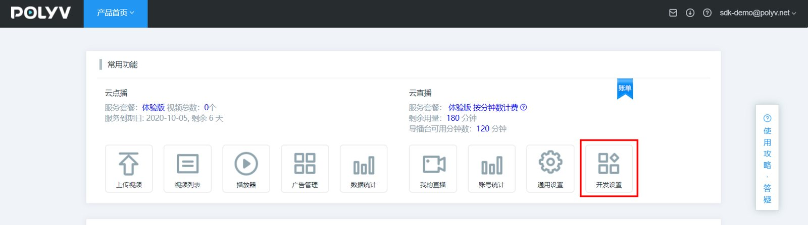
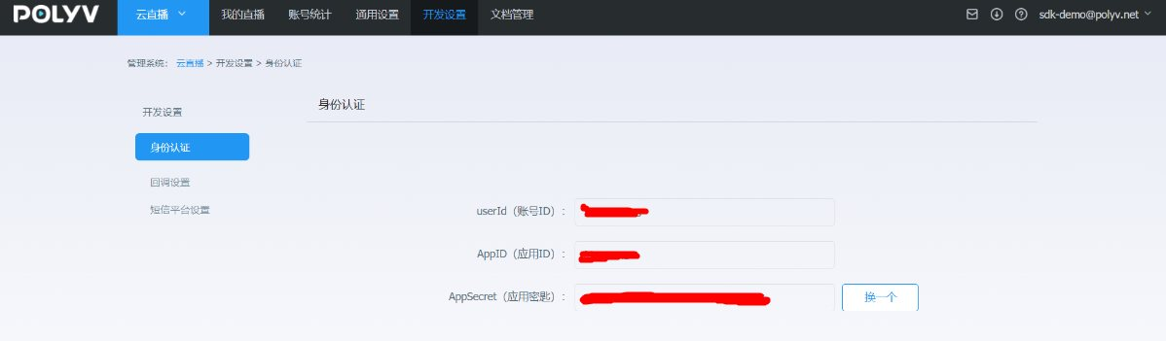

1.添加Maven依赖
&emsp;&emsp;将如下依赖加入到项目的POM文件中：
注意：受 Maven 中央仓库网络限制，阿里云云效 Maven 中央代理仓库可能会出现依赖查找不到的情况，建议使用中央仓库：https://repo1.maven.org/maven2/
<dependency>
<groupId>net.polyv</groupId>
<artifactId>polyv-java-live-sdk</artifactId>
<version>2.2.8</version>
</dependency>
注意：为了消除Java的冗长代码，SDK使用了jdk1.8的最新特性lombok，请在IntelliJ或者Eclipse 中配置对lombok的支持
<dependency>
<groupId>org.projectlombok</groupId>
<artifactId>lombok</artifactId>
<version>1.18.10</version>
</dependency>

2.初始化系统
&emsp;&emsp;在执行测试代码之前，需要B端先初始化系统配置，包括UserId \ AppId \ AppSecret , 如没有以上信息，请参考本文前提条件部分获取，初始化示例代码如下，任选一种：
/**
* 初始化配置,多账号支持，初始化时无需账号信息。调用时需传（2.1.0及以后版本支持）
*/
public static void initPolyvLive(){
LiveGlobalConfig.initMultiAccount();
log.debug("--初始化完成--");
}
/**
* 初始化配置并初始化 HTTP CLIENT 连接池超时时间和最大连接数配置
*/
public static void initPolyvLive(){
Integer timeOut = 20000; //HTTP CLIENT 连接池超时时间
Integer maxClientNum = 100; //HTTP CLIENT 最大连接数
LiveGlobalConfig.initMultiAccount( timeOut , maxClientNum);
log.debug("--初始化完成--");
}
/**
* 初始化配置并初始化 HTTP CLIENT 代理信息，一般使用在正式服务器不能连接外网，必须通过代理连接
*/
public static void initPolyvLive(){
String hostName = '127.0.0.1'; //代理的ip
int port = 8888; //代理的端口
String scheme = 'http'; // 代理的协议
LiveGlobalConfig.initMultiAccount( hostName, port, scheme);
log.debug("--初始化完成--");
}
/**
* 初始化配置,请配置自己的账号信息
*/
public static void initPolyvLive(){
String userId = "xxx";
String appId = "xxx";
String appSecret = "xxx";
LiveGlobalConfig.init(appId, userId, appSecret);
log.debug("--初始化完成--");
}
/**
* 初始化配置并初始化 HTTP CLIENT 连接池超时时间和最大连接数配置,请配置自己的账号信息
*/
public static void initPolyvLive(){
String userId = "xxx";
String appId = "xxx";
String appSecret = "xxx";
Integer timeOut = 20000; //HTTP CLIENT 连接池超时时间
Integer maxClientNum = 100; //HTTP CLIENT 最大连接数
LiveGlobalConfig.init( appId, userId, appSecret, timeOut , maxClientNum);
log.debug("--初始化完成--");
}
/**
* 初始化配置并初始化 HTTP CLIENT 代理信息，一般使用在正式服务器不能连接外网，必须通过代理连接,请配置自己的账号信息
*/
public static void initPolyvLive(){
String userId = "xxx";
String appId = "xxx";
String appSecret = "xxx";
String hostName = '127.0.0.1'; //代理的ip
int port = 8888; //代理的端口
String scheme = 'http'; // 代理的协议
LiveGlobalConfig.init( appId, userId, appSecret, hostName, port, scheme);
log.debug("--初始化完成--");
}
&emsp;&emsp;以上代码一般配置于随系统启动执行一次的全局初始化中，如用spring框架，可以参考如下：
package net.polyv.live.config;
import org.springframework.beans.BeansException;
import org.springframework.context.ApplicationContext;
import org.springframework.context.ApplicationContextAware;
import org.springframework.stereotype.Component;
import lombok.extern.slf4j.Slf4j;
/**
* 默认启动配置类
* @author: thomas
**/
@Slf4j
@Component
public class StartupListener implements ApplicationContextAware {
@Override
public void setApplicationContext(ApplicationContext applicationContext) throws BeansException {
String userId = "xxx";
String appId = "xxx";
String appSecret = "xxx";
LiveGlobalConfig.init(appId,userId,appSecret);
log.debug("--初始化完成--");
}
}

3.执行测试代码
&emsp;&emsp;测试创建一个直播频道，单元测试代码如下：
import org.junit.Assert;
import com.alibaba.fastjson.JSON;
import lombok.extern.slf4j.Slf4j;
import net.polyv.common.v1.exception.PloyvSdkException;
import net.polyv.live.v1.config.LiveGlobalConfig;
import net.polyv.live.v1.entity.channel.operate.LiveChannelRequest;
import net.polyv.live.v1.entity.channel.operate.LiveChannelResponse;
import net.polyv.live.v1.service.channel.impl.LiveChannelOperateServiceImpl;
/**
* @author: thomas
**/
@Slf4j
public class LiveChannelDemo {
/**
* 调用demo，必须处理PloyvSdkException。
*
* 参数合法性校验：SDK采用自定义验证框架对输入参数进行校验，如有参数不合格，将抛出PloyvSdkException异常，exception的message
* 包括具体校验不通过的字段信息，此异常是运行时异常，必须捕获处理相关业务逻辑；
*
* 解析返回数据：解析返回数据，如SDK调用正常成功，将封装响应对象，正常返回，如服务器返回错误信息，SDK将将抛出PloyvSdkException异常，exception的message
* 包括具体服务器执行错误信息，此异常是运行时异常，必须捕获处理相关业务逻辑；
* @param args
*/
public static void main(String[] args) {
//全局初始化，此处应该全局执行一次
String userId = "xxx";
String appId = "xxx";
String appSecret = "xxx";
LiveGlobalConfig.init(appId,userId,appSecret);
log.debug("--初始化完成--");
try {
//封装API请求对象
LiveChannelV2Request liveChannelRequest = new LiveChannelV2Request();
liveChannelRequest.setNewScene("alone")
.setTemplate("alone")
.setName("Spring 知识精讲") //设置频道主题信息
.setChannelPasswd("666888"); //设置频道密码
//调用SDK请求保利威服务器
LiveChannelV2Response liveChannelResponse = new LiveChannelOperateServiceImpl().createChannelV2(
liveChannelRequest);
Assert.assertNotNull(liveChannelResponse);
//正常返回做B端正常的业务逻辑
if (liveChannelResponse != null) {
//to do something ......
log.debug("频道创建成功{}", JSON.toJSONString(liveChannelResponse));
log.debug("网页开播地址：https://live.polyv.net/web-start/login?channelId={} , 登录密码： {}",liveChannelResponse.getChannelId(),liveChannelRequest.getChannelPasswd());
log.debug("网页观看地址：https://live.polyv.cn/watch/{} ",liveChannelResponse.getChannelId());
}
} catch (PloyvSdkException e) {
//参数校验不合格 或者 请求服务器端500错误，错误信息见PloyvSdkException.getMessage()
log.error(e.getMessage(), e);
// 异常返回做B端异常的业务逻辑，记录log 或者 上报到ETL 或者回滚事务
} catch (Exception e) {
log.error("SDK调用异常", e);
}
}
}
&emsp;&emsp;执行代码后，控制台应有如下关键输出，表示整合完成：
[main] DEBUG HttpUtil - http 请求 url: https://api.polyv.net/live/v2/channels/ , 请求参数: {"requestId":"2860257a405447e1bbbe9161da2dee72","appId":"frlr1zazn3","name":"Spring 知识精讲","sign":"EC98FB94BF6DADA722F1C9A7AA0E9C0E","channelPasswd":"666888","userId":"1b448be323","timestamp":"1603435147307"}
[main] DEBUG HttpUtil - http 请求结果: {"code":200,"status":"success","message":"","data":{"channelId":1972796,"userId":"1b448be323","name":"Spring 知识精讲","publisher":"主持人","description":"","url":"rtmp://push-d1.videocc.net/recordf/1b448be3231603435207373ea0f?auth_key=1603437007-0-0-bdbbb7f070573d80424a69c99c52ed0a","stream":"1b448be3231603435207373ea0f","logoImage":"","logoOpacity":1.0,"logoPosition":"tr","logoHref":"","coverImage":"","coverHref":"","waitImage":"","waitHref":"","cutoffImage":"","cutoffHref":"","advertType":"NONE","advertDuration":0,"advertWidth":0,"advertHeight":0,"advertImage":"","advertHref":"","advertFlvVid":"","advertFlvUrl":"","playerColor":"#666666","autoPlay":false,"warmUpFlv":"","passwdRestrict":false,"passwdEncrypted":"","isOnlyAudio":"N","isLowLatency":"N","m3u8Url":"http://pull-d1.videocc.net/recordf/1b448be3231603435207373ea0f.m3u8?auth_key=1603435207-0-0-56b60df63374403e22821f79a681989f","m3u8Url1":"","m3u8Url2":"","m3u8Url3":"","channelLogoImage":"http://liveimages.videocc.net/assets/wimages/pc_images/logo.png","scene":"alone","channelViewerPasswd":null,"channelPasswd":"666888","linkMicLimit":0,"streamType":"client","pureRtcEnabled":"N","type":"transmit","currentTimeMillis":1603435207694}}
[main] DEBUG LiveChannelDemo - 频道创建成功{"advertDuration":0,"advertFlvUrl":"","advertFlvVid":"","advertHeight":0,"advertHref":"","advertImage":"","advertType":"NONE","advertWidth":0,"autoPlay":false,"channelId":1972796,"coverHref":"","coverImage":"","currentTimeMillis":1603435207694,"cutoffHref":"","cutoffImage":"","description":"","isLowLatency":"N","isOnlyAudio":"N","linkMicLimit":0,"logoHref":"","logoImage":"","logoOpacity":1,"logoPosition":"tr","m3u8Url":"http://pull-d1.videocc.net/recordf/1b448be3231603435207373ea0f.m3u8?auth_key=1603435207-0-0-56b60df63374403e22821f79a681989f","m3u8Url1":"","m3u8Url2":"","m3u8Url3":"","name":"Spring 知识精讲","passwdEncrypted":"","passwdRestrict":false,"playerColor":"#666666","stream":"1b448be3231603435207373ea0f","url":"rtmp://push-d1.videocc.net/recordf/1b448be3231603435207373ea0f?auth_key=1603437007-0-0-bdbbb7f070573d80424a69c99c52ed0a","userId":"1b448be323","waitHref":"","waitImage":"","warmUpFlv":""}
&emsp;&emsp;还可以官网登录验证创建是否成功；
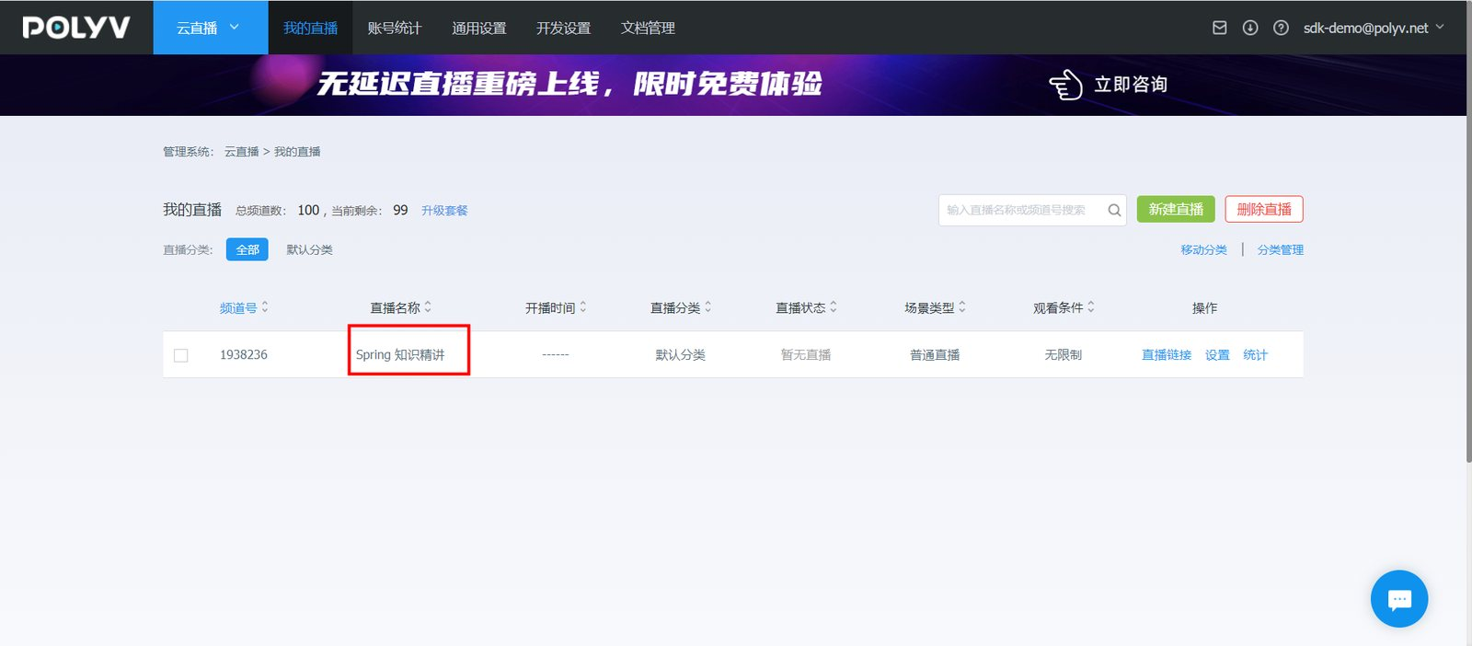
&emsp;&emsp;至此，B端已经完成保利威直播Java SDK安装配置，可以使用直播SDK进行其他功能开发和测试，如B端接入过程有任何问题，直接使用右下角在线客服找到售后技术支持提问 ，请将问题的运行环境、操作步骤、错误反馈信息、联系方式同步反馈，便于问题的快速定位和解决。

